H.U. MECHANICAL ENGINEERING

GENERAL CHEMISTRY LAB REPORT

The Molecular Weight of a Condensable Vapor

GÖKAY KART

KIM-121-6

ZÜHRA ÇINAR

**Aim**

Our aim in this experiment is to calculate the molecular weight of a volatile liquid using the balance of external and internal pressure.

**Boyle’s Law**

According to this law, temperatures are kept constant, an ideal gas is inversely proportional to its volume and pressure.

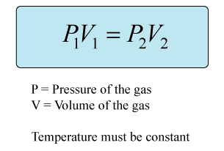

**Charles’ Law**

According to this law, the change of the volume of any ideal gas at constant pressure affects the change of its temperature at the same rate.

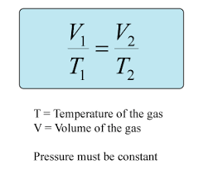

**Gay-Lussac Law**

According to this law, the pressure of a given ideal gas is directly proportional to its temperature specified in units of kelvin.

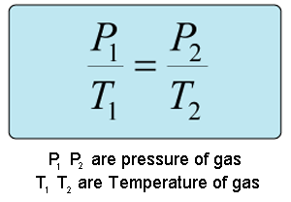

**Combined Gas Law**

The unified gas law is a combination of Boyle's Law, Charles's Law, and Gay-Lussac's Law. It states that the ratio of pressure to volume and the absolute temperature of a gas is equal to a constant.

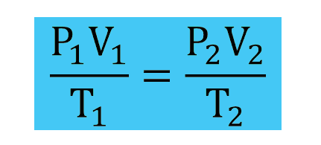

**Avogadro’s Law**

According to this law, gases of equal volume have the same number of particles or molecules at equal temperature and equal pressure.

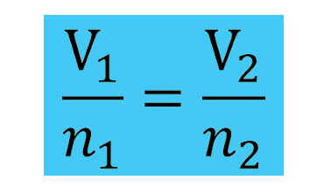

**Dalton’s Law**

According to this law, the total pressure of a gas mixture is equal to the sum of the partial pressures of the gases that make up the mixture.

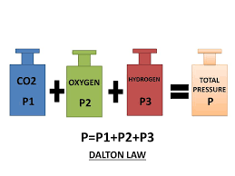

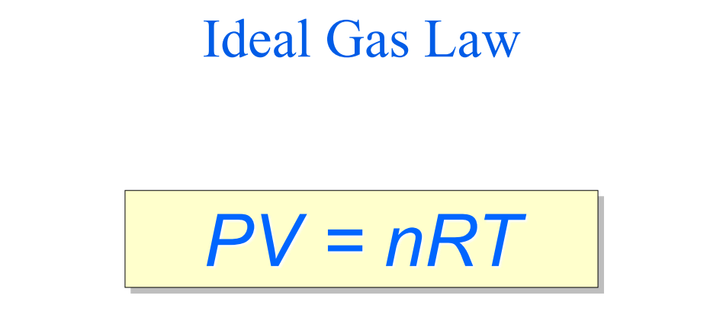

**What is the ideal gas?**

* Ideal gases do not attract or repel each other, so the push pull force is neglected.
* Ideal gas molecules themselves do not occupy any volume.
* The ideal gas does not really exist, there are gases close to ideal.
* 1 mole of ideal gas is 22.4 liters at 0°C 1 atm pressure.

The pressure (P), volume (V) and temperature (T) of an ideal gas are a simple formula called the ideal gas law.

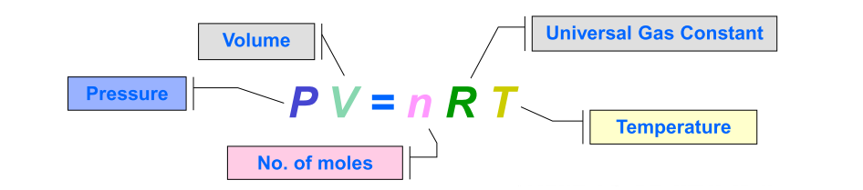

"R" in the formula is the international gas constant. The unit of "R" is atm.L/mol.K or kPa.L/mol.K. This constant is the same for all ideal gases.

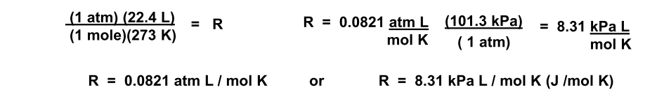

**Conversions used in ideal gas law questions:**

* 1 atm = 1,015.10(5)N/m2
* 1 atm = 760 mm Hg
* 1 atm = 101.3 kPa
* 1 L = 1000 ml
* K = °C + 273.15

**Data of the experiment;**

• m1= Mass of flask and aluminium foil = 36.22 (g)

• m2= Mass of flask, aluminium foil, and condensed liquid = 36.35 (g)

• T1= Temperature of boiling water = 96 (°C)

• P1= Pressure (mm Hg) = PBeytepe= 725 mm Hg

• V1= Volume of the flask = 64 (mL)

**Calculations of the experiment;**

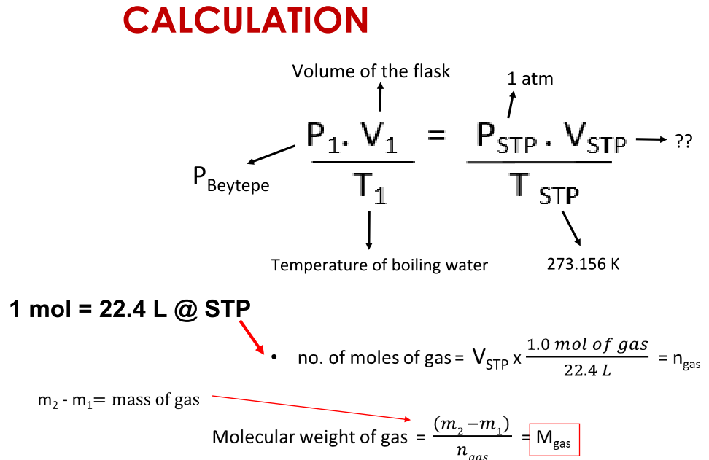

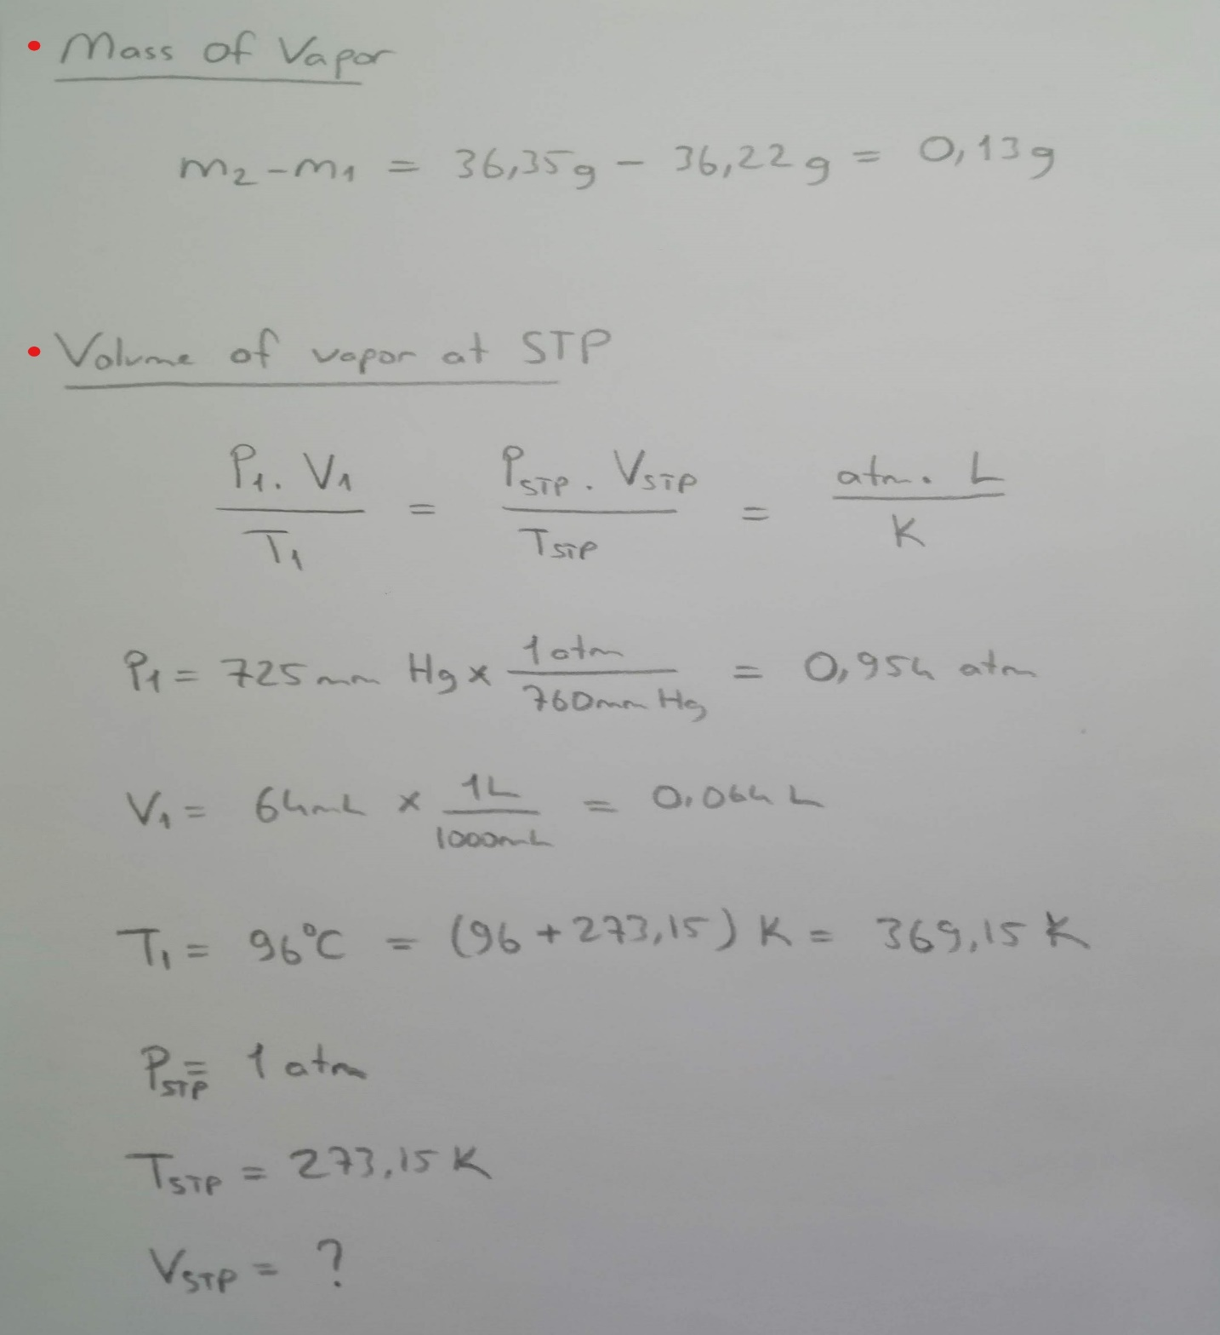

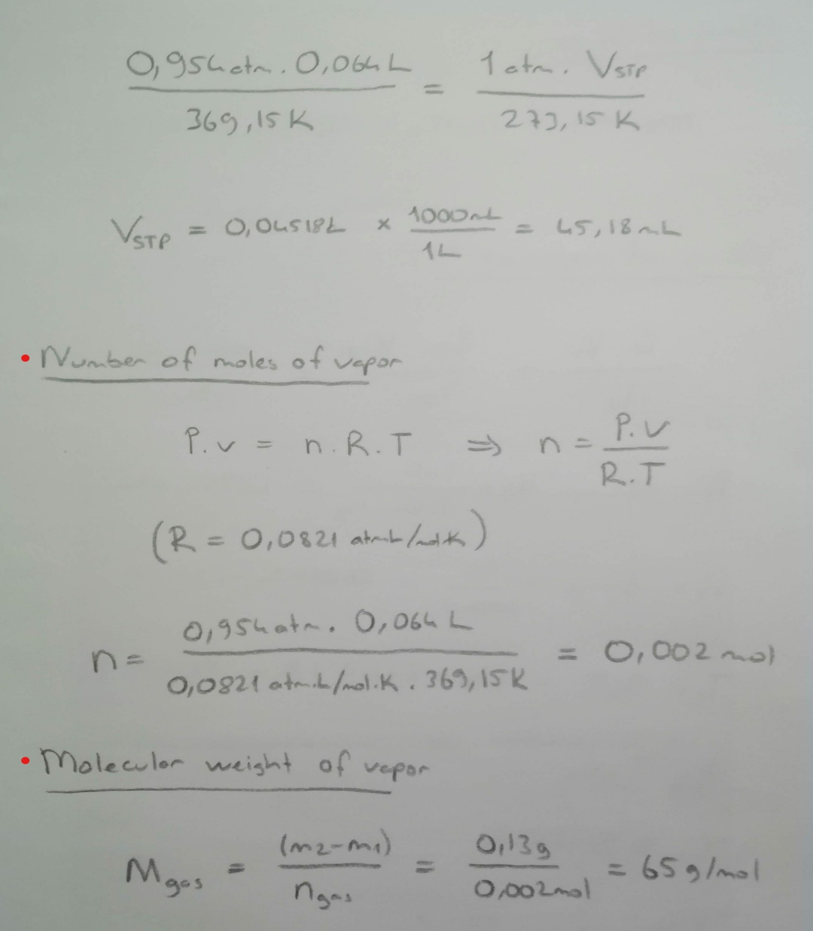

**metin içeren bir resim

Açıklama otomatik olarak oluşturuldu**

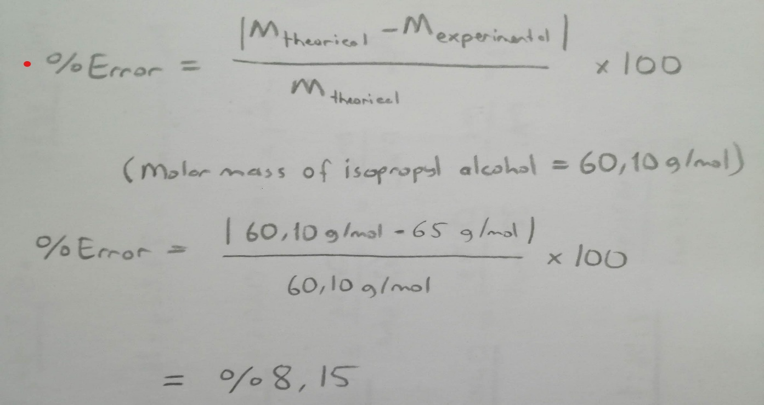

**Results of the experiment;**

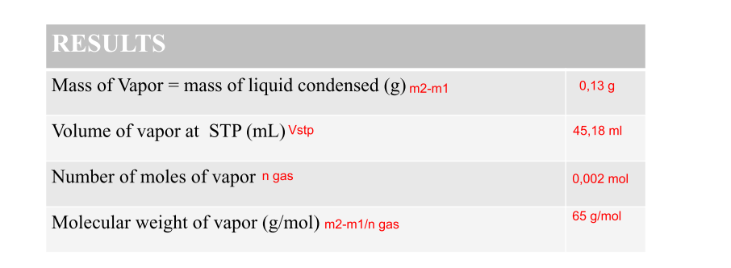

**Discussion part of the experiment;**

The aim of the experiment is to find out how close we get to its true value when we calculate the molar mass of the volatile substance.In the experiment we evaporated some isopropyl alcohol. We calculated its volume and weight and pressure. We found the number of moles and calculated the molar weight with the ideal gas equation.

In the experiment, an error was made in finding 8.15% molar mass according to the percentage error calculation. There are many reasons for this result.

The first cause of this error is that isopropyl alcohol is not an ideal gas and has repulsive and pulling forces between its molecules. 8.15% ratio is low due to the proximity of isopropyl alcohol to the ideal gas. Higher rate of error may occur with other gases.

The second factor may be due to the hole made in the aluminium foil, because the size of the hole should not be random.

The third factor may cause error because there is no complete evaporation or internal-external pressure compensation.

As a result, the requirements to improve the error rate in the experiment are listed below.

1-The bottle should not contain any foreign matter from previous tests.

2-The bottle should be carefully covered with aluminium foil.

3-The hole made in the foil is very important. It must be drilled enough to balance the external pressure and internal pressure. If it is too punctured, all volatile matter leaves the bottle.

4- In the bottle kept in a beaker, the process should not be terminated before evaporation is complete.

5-Mass and volumetric values in the experiment must be calculated with the right equipment.

However, since no gas is ideal, the experiment will never be accurate.

**Questions & Answers:**

**1-**A quantity of oxygen measuring 2.00 liters at standard conditions will occupy what volume at 800mm Hg pressure and 0 (°C)?

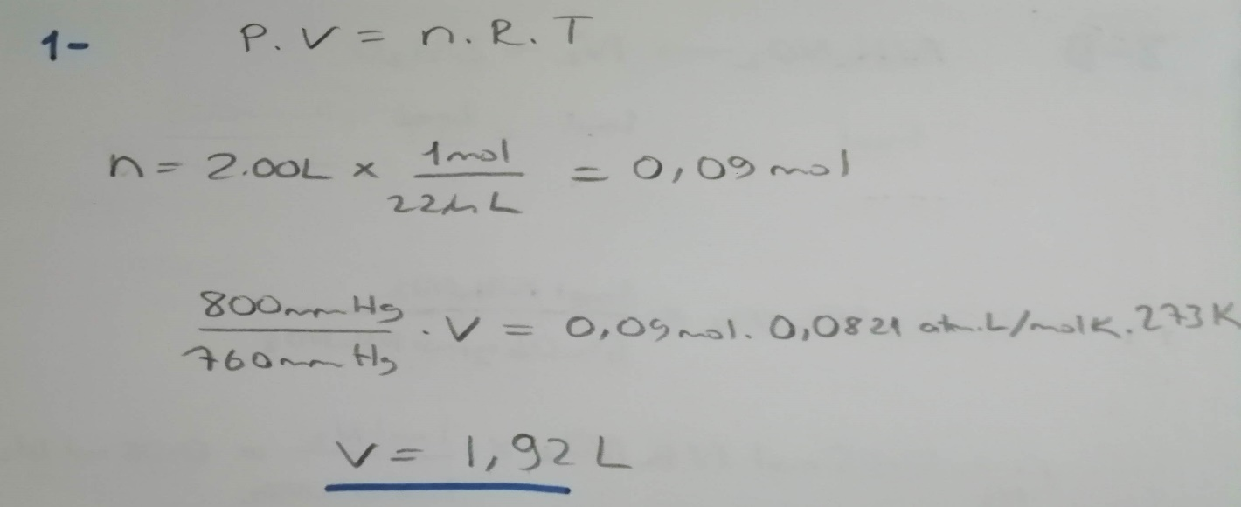

**2-**A 1.00 liter vessel filled with air at STP is sealed and heated to 273 (°C). What is the pressure of the air in the vessel now?

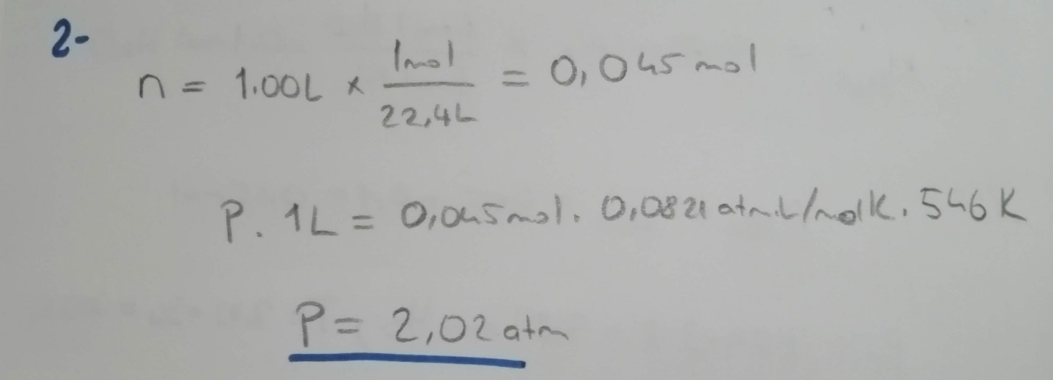

**3-**When heated, ammonium nitrate decomposes according to the equation

NH4NO2 --->>>N2 + 2H2O

**3a-**What weight of a ammonium nitrite must be decomposed to give 1.00 liter of nitrogen gas (N2) at STP?

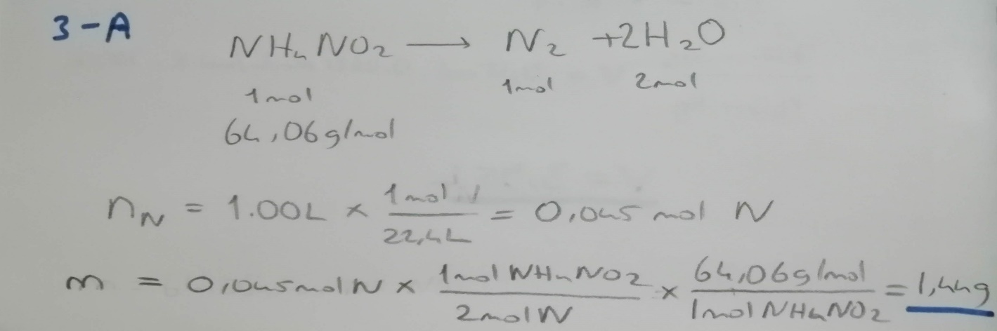

**3b-**What volume would the gaseous decomposition products of 3.20 g of ammonium nitrite occupy if collected over water at 750mm Hg and 30(°C)? The vapor pressure of water at this temperature is 32.0 mm Hg.

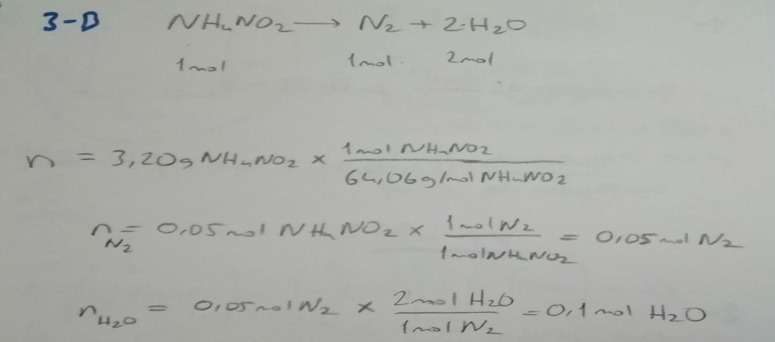

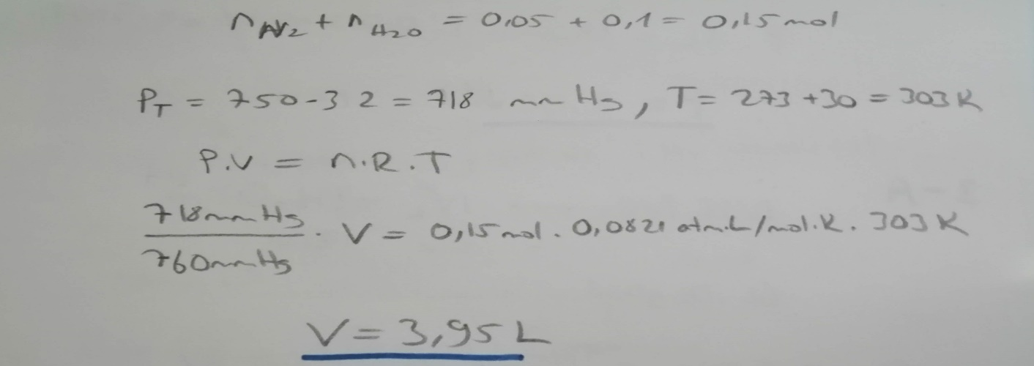

**4-**A 0.341 g sample of a gas occupies a volume of 355 ml at 8.7(°C) and 743 mm Hg. What is the molecular weight of this gas?

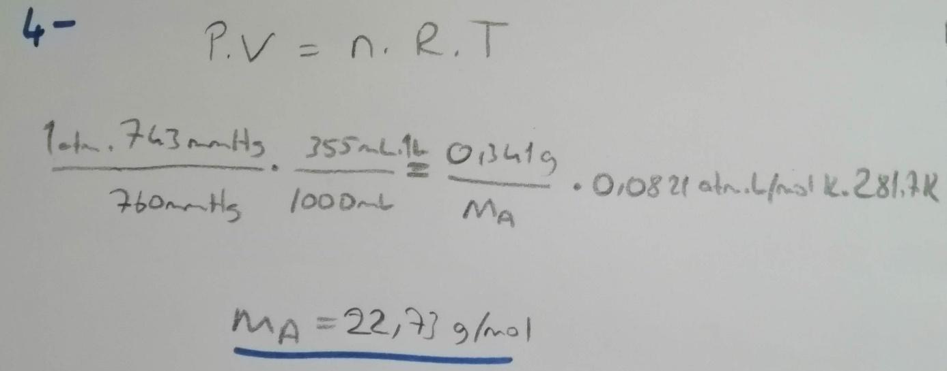

**Referenced sources:**

Websites:

<https://tr.wikipedia.org/>

<https://tr.khanacademy.org/science/physics/thermodynamics/>

<https://www.canlidershane.net/>

Books:

General Chemistry Principles and Modern Applications (10th Edition, Chapter 6).